Aircraft Design 1 – Fall 2025

Assignment 3: Wing Design

Student Names and USCIDs:

Aurelio Santiago, C30461119

Mateo Garcia, V02125756

Jacob Chin, C96554174

Instance 1

Hours spent on assignment: 23h

Aircraft type: Business Jet

Aircraft number: 110

Table 1: Requirements Table

|  |  |  |
| --- | --- | --- |
| Requirement Type | Value | Unit |
| Payload | 1100 | kg |
| Range | 3600 | km |
| Cruise Altitude | 12,192 | m |
| Cruise Speed | 830 | km/hr |
| Take-off Distance | 1200 | m |
| Landing Distance | 860 | m |
| Propulsion System | jet |  |

**Table of Contents**

1 – Introduction 4

2 – Clean Wing Design 4

2.1 – Infinite Wing 4

2.2 – Airfoil Selection 5

2.3 – Finite Wing and Aerodynamics Chord 5

2.4 – Clean Wing Lift Curve 6

2.4 Validation and Sanity Check 8

3 – High Lift Devices 9

3.1 – Landing and Take-Off Conditions 9

4 – Fuel Tank Volume 9

References: 9

Appendix 1: Technical Drawings 10

# 1 – Introduction

This report covers the entirety of the preliminary wing design, from clean wing to high-lift devices and fuel tank considerations. As the report progresses, more detail will be added to ensure the wing accomplishes all intended purposes: lift generation, flight control, compliance with take-off and landing requirements, and the possibility of fuel storage. The first section covers a clean wing design, which assumes a basic wing with no complex or moving mechanisms. The following section will introduce high-lift devices and control surfaces. The final inclusion will be for possible internal fuel tanks within the body of the wing once the available internal volume of the wing is approximately determined. Throughout the report, values will be sanity checked with similar aircraft in industry.

# 2 – Clean Wing Design

First and foremost, the wing itself must be designed initially with no high lift devices or other such structures to complicate it. Based on requirements for lift and performance, and airfoil will be selected and from there other parameters such as aspect ratio, wing area, span, and sweep angle will be taken from previous calculations or calculated anew to get a fully outlined shape for the wing. This will be the basis for future additions to the wing in other sections.

## 2.1 – Infinite Wing

Calculations for an infinite wing will be the start of airfoil considerations as lift is the initial driving requirement for selection (specifically, the lift coefficient). Two design lift coefficients will be calculated: total lift coefficient and airfoil lift coefficient (*cL,design* and *cl,design*).

First, a total lift coefficient. The total lift for take-off will be calculated by multiplying the take-off weight by 1.1 to account for negative lift from the tail as well as gusts and other such factors that may negatively affect lift during flight.

$$L=1.1L_{total}=1.1W_{TO}=1.1*163420.7695=179762.8465 N$$

Next, this lift value will be used to calculate a working cL value with the design average wing loading value of W/S = 2000 N/m2. Cruise conditions will be used as it is the most prevalent section of the mission profile. The initial definition for the cruising lift coefficient would be: $c_{L,design}=\frac{1}{\frac{1}{2}*ρ_{cruise}*v_{cruise}^{2}}*\frac{W}{S}$

As the weight is variable during cruise, there will be a calculated average cruise weight using fuel calculations from Assignment 2. The equation for the coefficient of lift becomes:

$$c_{L,design}=1.1*\frac{1}{\frac{1}{2}*ρ_{cruise}*v_{cruise}^{2}}*\left[\frac{1}{2}*\left({\frac{W}{S}}_{start of cruise}+{\frac{W}{S}}_{end of cruise}\right)\right]=0.2348464$$

This resulting value is for an unswept wing and thus must be changed for the sweep angle of the wing. From reference aircraft in similar conditions, an average sweep angle of 26.11o is observed and will be used as a starting value for calculations. The following equation estimates the design lift coefficient based on total lift coefficient and sweep angle:

$$c_{l,design}=\frac{c_{L,design}}{\cos^{2}(λ)}=0.2912799985$$

Now that there is an effective coefficient of lift, an appropriate airfoil can be selected.

## 2.2 – Airfoil Selection

With the coefficient of lift calculated, the search for the right airfoil begins. Since cruise conditions approach around Mach 0.78, some precautions must be taken to account for transonic flight. Specifically, a supercritical airfoil would delay transonic effects and ensure stable flight. Across all supercritical airfoil designs, the key detail is a relatively flat upper surface and a highly curved lower surface to allow lower drag while maintaining a high lift. The selected airfoil was a NASA SC(2)-0410, indicating a design lift coefficient of 0.4 and a max thickness of 10% of the chord. The following data is available for the airfoil at calculated cruise Reynolds numbers:

## 2.3 – Finite Wing and Aerodynamics Chord

The following section demonstrates the calculations done to establish the baseline wing geometry and ensures the selected parameters are reasonable, acceptable, and consistent with similar aircrafts.

From assignment 2 it was found that the wing surface area is 81.71m2 along with a chosen aspect ratio of 9. These values give us the wingspan to be 27.12m by using the equation below.

$b=\sqrt{A⋅S}=\sqrt{81.71⋅9}=27.12$ M

This means that each wing is 13.56m. The root chord is now chosen to be 4.9 to allow for a taper ratio value within the normal range of business jets.

$$λ=\frac{2b}{c_{r}⋅A}-1=\frac{2⋅27.12}{4.9⋅9}-1=0.22$$

Now having found the root chord and taper ratio, as well as knowing the values for the previous geometries, we can find the tip chord.

$λ=\frac{C_{t}}{C_{r}}⇒C_{t}=λ⋅C_{r}=0.26⋅4.9=1.13$ m

Moreover, the Mean Aerodynamic Chord (MAC) and the location of the MAC can now be calculated using the equations below.

$$\overline{Y} =\frac{b}{6}⋅\frac{1+2⋅λ}{1+λ}=\frac{27.12}{6}⋅\frac{1+2⋅0.22}{1+0.22}=5.36$$

$$MAC=\frac{2⋅C_{r}}{3}⋅\frac{1+λ+λ^{2}}{1+λ}=\frac{2⋅4.9}{3}⋅\frac{1+0.22+{0.22}^{2}}{1+0.22}=3.4$$

**2.3.1 - Sweep Angle (ΛLE, ΛTE and Λ0.25c)**

A leading edge sweep angle is assumed to be 25°. By using the following equations, the quarter chord and half chord sweep angles are found to be 21° and 17° respectively.

$$\tan{Λ_{0.25}}=\tan{Λ_{LE}}-\frac{1}{4}⋅\frac{2C_{r}}{b}⋅\left(1-λ\right)$$

$$\tan{Λ_{0.5}}=\tan{Λ_{LE}}-\frac{1}{2}⋅\frac{2C_{r}}{b}⋅\left(1-λ\right)$$

**2.3.2 - Cantilever Ratio & M(DD) Check**

The Cantilver Ratio is the ratio between the semi wingspan and maximum root thickness. It describes how slender or long the wing is relative to its root thickness, adjusted for sweep It also acts as a sanity check to see if cantilever ratio is within acceptable range in comparison to other aircraft. According to the slide 135 in Wing sizing slides typical cantilever ratio value lie between 18 and 22. If cantilever ratio does not fall within range, then wing parameters should likely be changed.

Cantilever Ratio = $\frac{\frac{b}{2}}{t_{r}cosΛ_{.50c}}$ = 29.5

With a wingspan of 27.12, and root thickness t(r) = 0.48, and a half chord sweep angle of 18.54 the cantilever ratio resulted in 29.5 which exceeds the range of 18 – 22. Through thorough analysis our cantilever ratio value is large due to the wingspan value. The Wing area was calculated through the square root of the aspect ratio * the wing area. Our wing area value of 81.71 meters squared is twice the amount of reference aircraft average wing area value which means that our wing area must be close to twice as small.

**2.3.3 M(DD) Check**

Mach Drag Divergence number will give us the Mach number where wave drag dominates, the drag coefficient increases rapidly. High drag is undesirable to aircraft performance, so it is important that our aircraft avoids flying to this Mach number. According to NASA technical paper 2969 the airfoil NASA SC(2) 0404 has a Mach Drag Divergence number of 0.875

Mach Drag Divergence Number should always be greater than the Mach critical number, around 6% higher than Mach Critical number. Meaning the Mach Critical Number would be at a value of 0.82 which is higher than our cruise mach number of 0.78

## 2.4 – Clean Wing Lift Curve

Before the wing lift curve can be fully defined, several key aerodynamic angles must be determined. These include the lift-curve slope, the trim angle of attack, and the stall angle, which together establish the shape and limits of the wing’s lift behaviour. Once these parameters are obtained, the complete lift curve for the aircraft can be constructed, serving as a foundation for subsequent performance analyses.

2.4.1 - Cl a calculation at cruise and take off/landing

$β_{cruise}=\sqrt{1-M_{eff}^{2}}=\sqrt{1-{0.78}^{2}}$ = 0.62577

$β_{landing}=\sqrt{1-M_{eff}^{2}}=\sqrt{1-{0.11}^{2}}$ = 0.99393

$$\frac{dC_{L}}{dα}=\frac{2⋅π⋅A}{2+\sqrt{4+{\left(\frac{Aβ}{η}\right)}^{2}⋅\left(1+\frac{\tan^{2}\left(Λ_{0.5c}\right)}{β^{2}}\right)}}$$

With a span efficiency factor of 0.95, aspect ratio of 9, span efficiency factor of 0.95 for cruise condition dCL/d(alpha) = 6.2713/rad or 0.10945/deg. for landing condition dCL/d(alpha) = 4.659/rad or 0.0813/deg

$$C_{l}=\frac{2πα}{\sqrt{1-M_{inf}^{2}}}$$

$$α_{trim}=\frac{C_{L,des}}{C_{Lα}}+α_{0L}$$

$$Λ>\frac{4}{\left(C_{1}+1\right)cosΛ_{LE}}$$

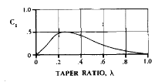

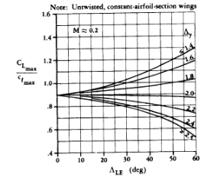

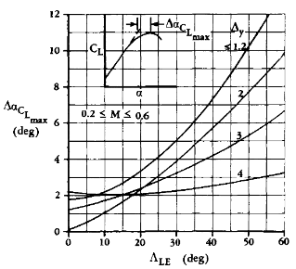

2.3.5 - Cl a curve at cruise and during takeoff/landing

## 2.4 Validation and Sanity Check

The following subsections will conduct validity, and consistency checks to confirm that all values remain within reasonable limits. By cross-referencing the calculated parameters with the reference graphs below, these values can be verified against established historical trends.

**2.4.1 Taper Ratio**

In Figure 1 the established taper ratio and quarter chord sweep would be enough to provide efficient performance, as the point of intersection falls on the historical trend line by Raymer. Taper ratios below 0.2 should be avoided as this tends to promote tip stall, with our calculated taper ratio of 0.22 we avoid this issue. This signifies that there should be low induced drag due to the lift distribution begin close to the ideal elliptical profile.

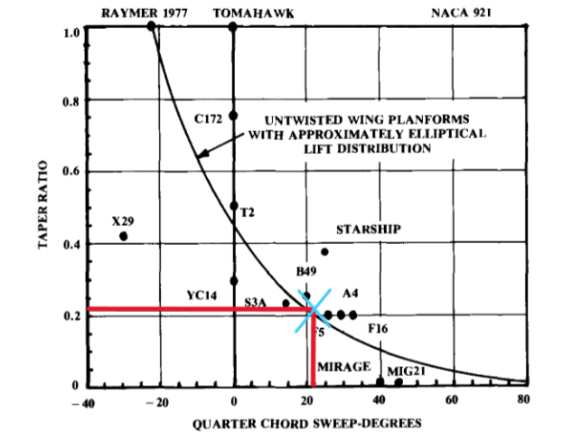

*Figure 1: Effects of sweep on desired taper ratio*

**2.4.2 Sweep Angle**

Furthermore, Raymer also proposed a way to validate the sweep angle by using historical references. From Figure 1.1 it can be clearly seen that the sweep angle that was chosen earlier at 25 can be cross-checked against the maximum Mach number, estimated to be 0.8, to confirm that the design aligns with established aerodynamic trends observed in prior aircraft designs.

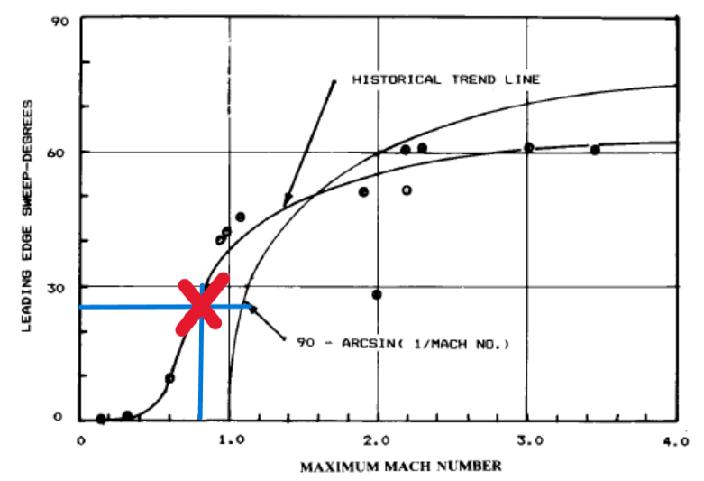

*Figure 1.1: Historical correlation between wing sweep angle and maximum Mach number.*

# 3 – High Lift Devices

These devices may need to be added if the current existing cLmax is adequate for all flight conditions. Specifically, landing and take-off will be analyzed first.

## 3.1 – Landing and Take-Off Conditions

In Assignment 2, the cLmax values for take-off and landing were assumed to be 2.2 and 2.6, respectively, based on similar aircraft trends. However, as the current calculated value is (#) it needs to increase by (#) and (#) to be able to perform at those conditions. Thus, high lift devices will be added to adjust the performance to different conditions within the mission profile. For safety, the differences will be increased by 10% to ensure they are well above the minimum requirements for each section to avoid stall behavior. The acting DcLmax for this will be (#) since it is the greatest difference.

## 3.2 – Selecting High Lift Devices

## 3.3 – Flapped CL-α Curves for Relevant Conditions

# 4 – Fuel Tank Volume

# References:

[2] – Harris, Charles; “NASA Technical Paper 2969: NASA Supercritical Airfoils, *A Matrix of Family-Related Airfoils*,” Published 1990 by NASA. [19900007394.pdf](https://ntrs.nasa.gov/api/citations/19900007394/downloads/19900007394.pdf)

[3] – Airfoil Tools; “NASA SC(2)-0410 airfoil,” [NASA SC(2)-0410 AIRFOIL (sc20410-il)](http://airfoiltools.com/airfoil/details?airfoil=sc20410-il)

# Appendix 1: Technical Drawings

The following technical drawings are of the completed wing design (in order):

1. Front View
2. Left View
3. Top View